**AUTOMATIC CAR PARKING SYSTEM**

Abstract

The concept of an automatic car parking system is shown in this study. Because of the increase in the number of vehicles on the road, traffic congestion is unavoidable. Everything in the world is becoming more automated, thus we designed a system that can detect the entry and exit of cars through the gate automatically. Using infrared(IR) sensors located at the entry and exit, this automated car parking system decreases the time it takes to look for availability parking spaces by displaying the available spaces on LCD display.

Table of contents

1 .**Introduction** **1**

**2.** **Requirements** **2**

2.1 High Level Requirements 2

2.2 Low Level Requirements 2

2.3 SWOT analysis 3

2.4 5W's and 1H 4

3. **Architecture** **5**

3.1 Block Diagram Of Automatic Car Parking System 5

3.1.1 Components 6

3.2 UML diagrams 8

3.2.1 Behavioral diagram 8

3.3 Structural diagram 9

3.3.1 Use case diagram 9

4. **Applications** **10**

# 

# 

# 

# 

# 

# 

# Introduction

Car parking is a huge issue in today’s congested cities,as the number of automobiles increases. In congested and densely populated urban areas, the availability of parking spots is growing severe, so car parking is a major concern. As a result, effective parking management systems are required. In this project we employed sensors to detect if a parking is occupied , as well as servo motor to emulate gain opening motors. LCD is used to see the availability of empty slots.

Identifying features

1. IR Sensors are provided for easy detection of movement of vehicles.

2. LCD to be used to see the status of the availability of parking slots.

3. Servo motors for simulation as gate opener motors.

State of art/Research

Car parking is a huge issue in today's congested cities, as the number of automobiles increases. In congested and densely populated urban areas,

the unavailability of parking spots is growing severe, so car parking is a major concern. As a result, effective parking management systems are required.

# 

# 

# Requirements

## High Level Requirements

|  |  |
| --- | --- |
| ID | DESCRIPTION |
| HLR01 | The shall sense the availability of empty slots |
| HLR02 | The system shall able to open and close the gate |
| HLR03 | Shall be able to display the status of availability |
| HLR04 | Shall be able to allow new cars |

## Low Level Requirements

|  |  |
| --- | --- |
| ID | DESCRIPTION |
| LLR01 | IR Sensors are used to sense the availability of empty slots |
| LLR02 | The system shall use servo motor to open and close the gate |
| LLR03 | On a 162 LCD, visitors may observe the status of the available free parking space outside the parking lo |
| LLR04 | When the slots are empty it shall be able to allow new cars |

SWOT analysis

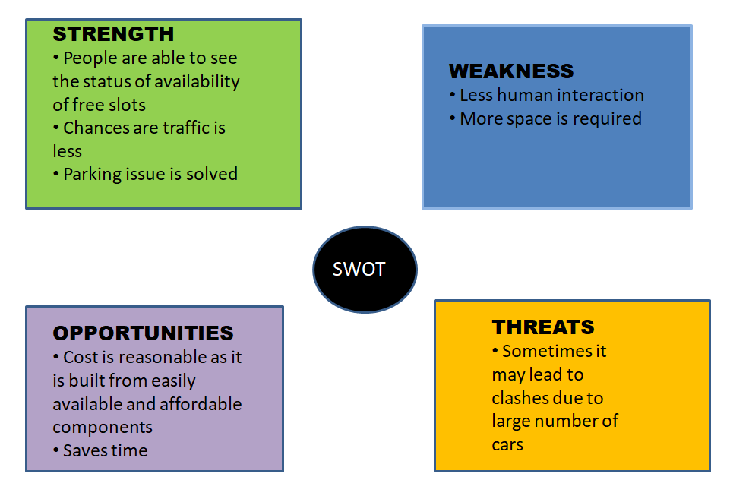

## 5W's and 1H

Who

People using their cars

What

Car parking system

When

When they want to park their cars

where

In parking areas

Why

TO avoid clashes and traffic

How

Using sensors and motors

# Architecture

## Block Diagram Of Automatic Car Parking System

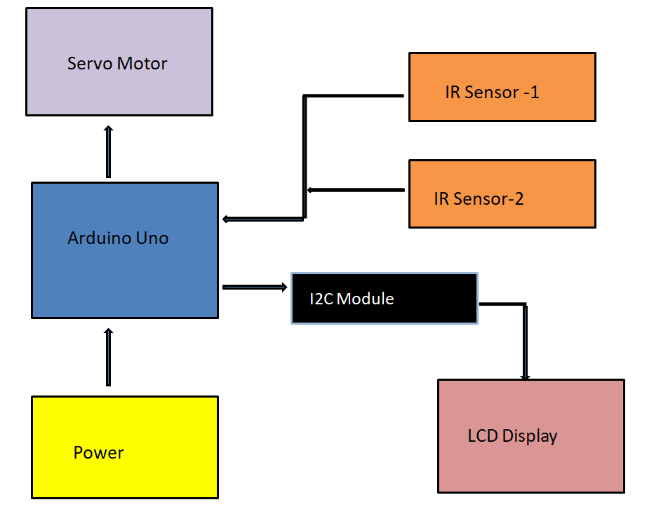

Components

* Arduino Uno

All sensors ,motors and peripherals are interfaced with Arduino Uno. Arduino senses the data and sends commands to LCD and Motors

* IR Sensor

IR Sensors are used to sense the availability of empty slots

* Servo Motor

The system shall use servo motor to open and close the gate

* I2C Module

Enables communication between Arduino and LCD

* LCD Display

On LCD, visitors may observe the status of the available free parking space outside the parking lot.

## UML diagrams

### Behavioral diagram

#### Flow chart

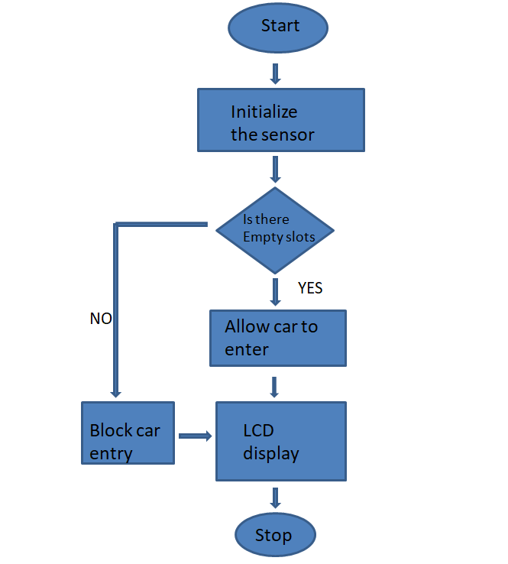

### Structural diagram

#### Use case diagram

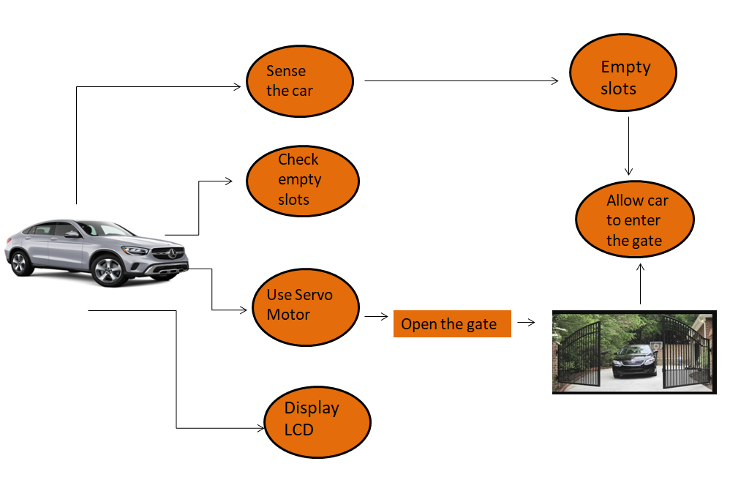

# Applications

Useful wherever parking is available like;

Airports

Bus stops

Railway stations

School and Collages etc...

# 

# Test plan

|  |  |  |  |
| --- | --- | --- | --- |
| Test ID | Test case objective | Input data | Expected output |
| TC_01 | If car arrives | car | Sensor should sense that car has arrived |
| TC_02 | If car is present | Sensor input | Check the availability of empty slots |
| TC_03 | If there is empty slot | Servo motor input | Open the gate |
| TC_04 | No empty slot | Servo motor | Block the gate |
| TC_05 | Open/Close gate | Servo motor | Display on LCD |

# 